**Who is in God’s Kingdom?**

**Reading:** Matthew 13:47-49

Also, God’s kingdom is like a net that was put into the lake. The net caught many different kinds of fish. It was full, so the fishermen pulled it to the shore. They sat down and put all the good fish in baskets. Then they threw away the bad fish. It will be the same at the end of time. The angels will come and separate the evil people from the godly people.

**Thought about the reading**

Jesus told lots of stories to help us understand what the kingdom of God is like. These stories are called parables.

The story today is a parable that tells us something about the kingdom of God. Jesus said that the kingdom is like a big net which fishermen used to catch fish. The net caught lots of different kinds of fish.

Just like there were lots of different kinds of fish in the net, there are lots of different sorts of people in God’s kingdom. Anyone can belong to this kingdom. You don’t have to be handsome or pretty, clever or rich. Jesus welcomes everyone.

But, if we want to be part of God’s kingdom then we must recognise that Jesus is the king and want to follow him. We must give him our lives and do what he tells us.

Those who do not recognise Jesus is the king are like the bad fish. They are not part of God’s kingdom.

**Prayer**

Lord Jesus, thank you that you want me to be part of your kingdom. Thank you that you welcome everyone, including me.

Lord Jesus, I know that you are king. I want you to be king in my life. Please help me to follow you and to do what you want.

Amen

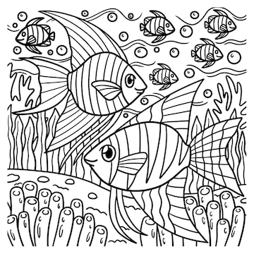

**Cambridge Causeway**

Spring 2023

Bible Study notes

**The Kingdom of God**

**2. Who is in God’s Kingdom?**

By Chrissy Cole